Cycling in Lund
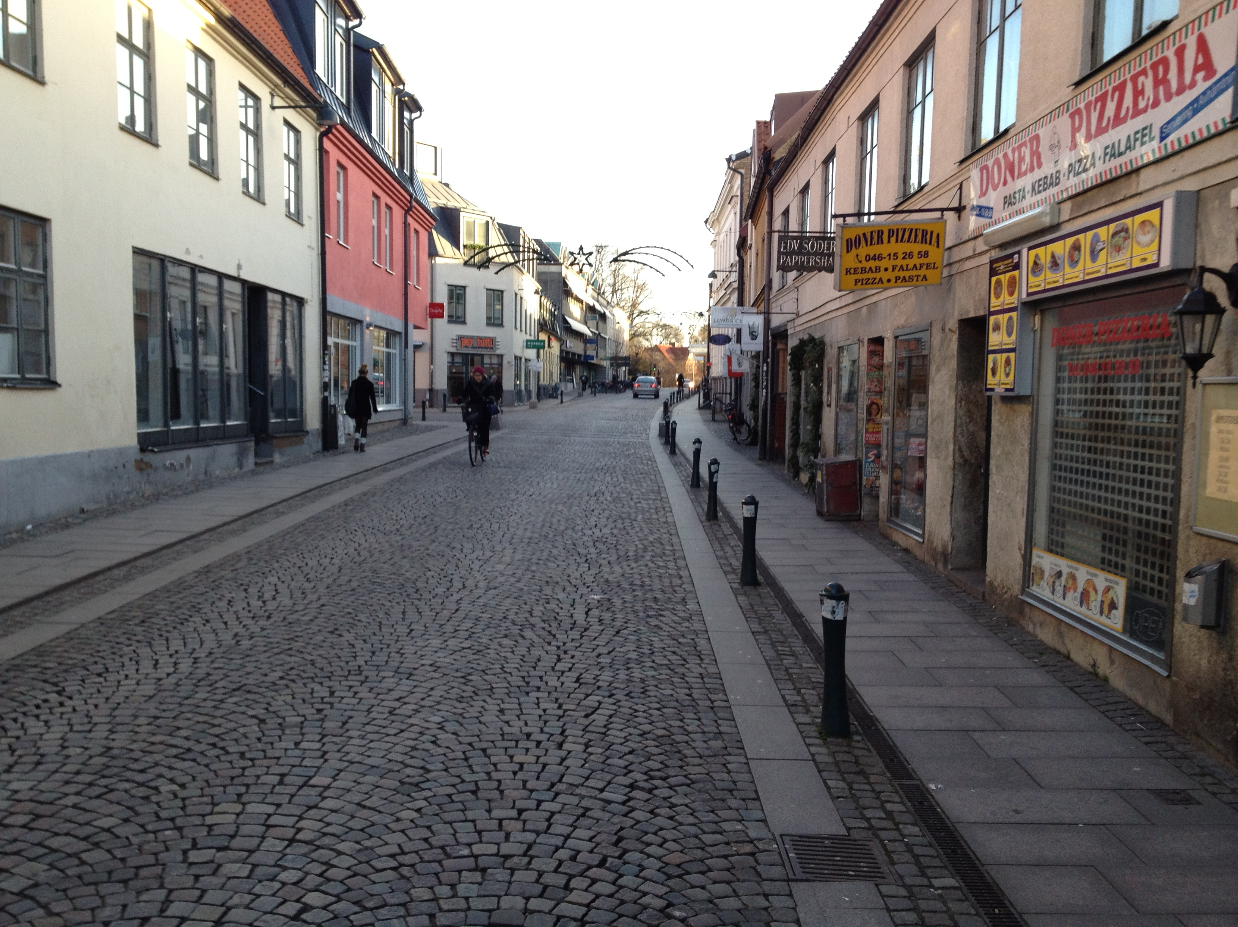
Lund is a university town in the county of Skäne, Sweden. It is about 30 minutes by train to Copenhagen. As a town, it has a lovely character with many narrow streets, market squares, shopping, a large research hospital, a sprawling university campus, and business parks on the E22 motorway. Doesn't this sound a lot like Cambridge?

Lund also has a strong cycling culture. Most people don't drive cars around the city. Cycles are everywhere. In fact, on the first day there, a Friday, I saw only 7 cars on the two-mile journey from the centre to the business parks for a meeting. Admittedly I didn't follow the main roads, but this is still amazing. And this was between 8.30 and 8.45 in the morning. I saw a few buses from afar, and a few pedestrians, and a lot of bikes.

